EBS Volume

Snapshot

Volume

ELASTIC IPS address---- static Ip(wont change)

What is EBS Volume?

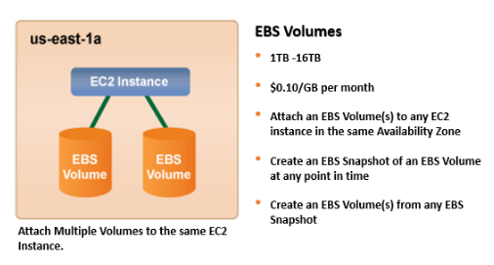

An Elastic Block Storage (EBS) Volume hosts virtual data in segments. It's like a storage disk with the ability to contain various sizes of data. These virtual storage devices usually replicate within one AWS region to increase their availability.

Types of volumes:

Solid state drives (SSD) — Optimized for transactional workloads involving frequent read/write operations with small I/O size, where the dominant performance attribute is IOPS. SSD-backed volume types include:

General Purpose SSD volumes

Provisioned IOPS SSD volumes

Hard disk drives (HDD) — Optimized for large streaming workloads where the dominant performance attribute is throughput. HDD-backed volume types include Throughput Optimized HDD and Cold HDD volumes.

Previous generation — Hard disk drives that you can use for workloads with small datasets where data is accessed infrequently and performance is not of primary importance. We recommend that you consider a current generation volume type instead. For more information, see Previous generation Magnetic volumes.

Volume types:

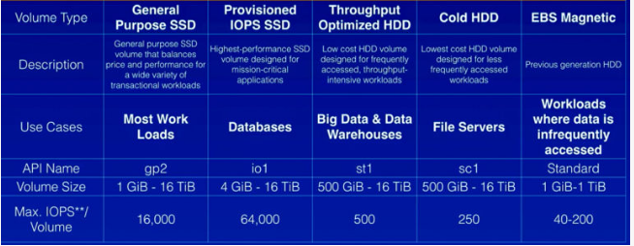

1General Purpose SSD volumes

2Provisioned IOPS SSD volumes

3Throughput Optimized HDD and Cold HDD volumes

4Previous generation Magnetic volumes

EBSlink:

<https://docs.aws.amazon.com/AWSEC2/latest/UserGuide/ebs-volumes.html>

<https://docs.aws.amazon.com/AWSEC2/latest/UserGuide/ebs-volume-types.html>

<https://docs.aws.amazon.com/AWSEC2/latest/UserGuide/AmazonEBS.html>

* [Features of Amazon EBS](https://docs.aws.amazon.com/AWSEC2/latest/UserGuide/AmazonEBS.html#ebs-features)
* [Amazon EBS volumes](https://docs.aws.amazon.com/AWSEC2/latest/UserGuide/ebs-volumes.html)
* [Amazon EBS snapshots](https://docs.aws.amazon.com/AWSEC2/latest/UserGuide/EBSSnapshots.html)
* [Amazon Data Lifecycle Manager](https://docs.aws.amazon.com/AWSEC2/latest/UserGuide/snapshot-lifecycle.html)
* [Amazon EBS data services](https://docs.aws.amazon.com/AWSEC2/latest/UserGuide/ebs-data-services.html)
* [Amazon EBS and NVMe on Linux instances](https://docs.aws.amazon.com/AWSEC2/latest/UserGuide/nvme-ebs-volumes.html)
* [Amazon EBS–optimized instances](https://docs.aws.amazon.com/AWSEC2/latest/UserGuide/ebs-optimized.html)
* [Amazon EBS volume performance on Linux instances](https://docs.aws.amazon.com/AWSEC2/latest/UserGuide/EBSPerformance.html)
* [Amazon CloudWatch metrics for Amazon EBS](https://docs.aws.amazon.com/AWSEC2/latest/UserGuide/using_cloudwatch_ebs.html)
* [EventBridge for Amazon EBS](https://docs.aws.amazon.com/AWSEC2/latest/UserGuide/ebs-cloud-watch-events.html)
* [Amazon EBS quotas](https://docs.aws.amazon.com/AWSEC2/latest/UserGuide/ebs-resource-quotas.html)

What is Volume?

An Amazon EBS volume is a durable, block-level storage device that you can attach to your instances. After you attach a volume to an instance, you can use it as you would use a physical hard drive. EBS volumes are flexible. For current-generation volumes attached to current-generation instance types, you can dynamically increase size, modify the provisioned IOPS capacity, and change volume type on live production volumes

You can use EBS volumes as primary storage for data that requires frequent updates, such as the system drive for an instance or storage for a database application. You can also use them for throughput-intensive applications that perform continuous disk scans. EBS volumes persist independently from the running life of an EC2 instance.

You can attach multiple EBS volumes to a single instance. The volume and instance must be in the same Availability Zone. Depending on the volume and instance types, you can use [Multi-Attach](https://docs.aws.amazon.com/AWSEC2/latest/UserGuide/ebs-volumes-multi.html) to mount a volume to multiple instances at the same time.

Amazon EBS provides the following volume types: General Purpose SSD (gp2 and gp3), Provisioned IOPS SSD (io1 and io2), Throughput Optimized HDD (st1), Cold HDD (sc1), and Magnetic (standard). They differ in performance characteristics and price, allowing you to tailor your storage performance and cost to the needs of your applications. For more information, see [Amazon EBS volume types](https://docs.aws.amazon.com/AWSEC2/latest/UserGuide/ebs-volume-types.html).

Your account has a limit on the number of EBS volumes that you can use, and the total storage available to you. For more information about these limits, and how to request an increase in your limits, see [Amazon EC2 service quotas](https://docs.aws.amazon.com/AWSEC2/latest/UserGuide/ec2-resource-limits.html).

Volume link :

<https://docs.aws.amazon.com/AWSEC2/latest/UserGuide/ebs-volumes.html>

**Contents**

* [Benefits of using EBS volumes](https://docs.aws.amazon.com/AWSEC2/latest/UserGuide/ebs-volumes.html#EBSFeatures)
* [Amazon EBS volume types](https://docs.aws.amazon.com/AWSEC2/latest/UserGuide/ebs-volume-types.html)
* [Constraints on the size and configuration of an EBS volume](https://docs.aws.amazon.com/AWSEC2/latest/UserGuide/volume_constraints.html)
* [Create an Amazon EBS volume](https://docs.aws.amazon.com/AWSEC2/latest/UserGuide/ebs-creating-volume.html)
* [Attach an Amazon EBS volume to an instance](https://docs.aws.amazon.com/AWSEC2/latest/UserGuide/ebs-attaching-volume.html)
* [Attach a volume to multiple instances with Amazon EBS Multi-Attach](https://docs.aws.amazon.com/AWSEC2/latest/UserGuide/ebs-volumes-multi.html)
* [Make an Amazon EBS volume available for use on Linux](https://docs.aws.amazon.com/AWSEC2/latest/UserGuide/ebs-using-volumes.html)
* [View information about an Amazon EBS volume](https://docs.aws.amazon.com/AWSEC2/latest/UserGuide/ebs-describing-volumes.html)
* [Replace a volume using a previous snapshot](https://docs.aws.amazon.com/AWSEC2/latest/UserGuide/ebs-restoring-volume.html)
* [Restore a root volume](https://docs.aws.amazon.com/AWSEC2/latest/UserGuide/replace-root.html)
* [Monitor the status of your volumes](https://docs.aws.amazon.com/AWSEC2/latest/UserGuide/monitoring-volume-status.html)
* [Detach an Amazon EBS volume from a Linux instance](https://docs.aws.amazon.com/AWSEC2/latest/UserGuide/ebs-detaching-volume.html)
* [Delete an Amazon EBS volume](https://docs.aws.amazon.com/AWSEC2/latest/UserGuide/ebs-deleting-volume.html)

## Benefits of using EBS volumes

EBS volumes provide benefits that are not provided by instance store volumes.

**Topics**

* [Data availability](https://docs.aws.amazon.com/AWSEC2/latest/UserGuide/ebs-volumes.html#availability-benefit)
* [Data persistence](https://docs.aws.amazon.com/AWSEC2/latest/UserGuide/ebs-volumes.html#persistence-benefit)
* [Data encryption](https://docs.aws.amazon.com/AWSEC2/latest/UserGuide/ebs-volumes.html#encryption-benefit)
* [Data security](https://docs.aws.amazon.com/AWSEC2/latest/UserGuide/ebs-volumes.html#security-benefit)
* [Snapshots](https://docs.aws.amazon.com/AWSEC2/latest/UserGuide/ebs-volumes.html#backup-benefit)
* [Flexibility](https://docs.aws.amazon.com/AWSEC2/latest/UserGuide/ebs-volumes.html#flexibility-benefit)

What is Snapshot?

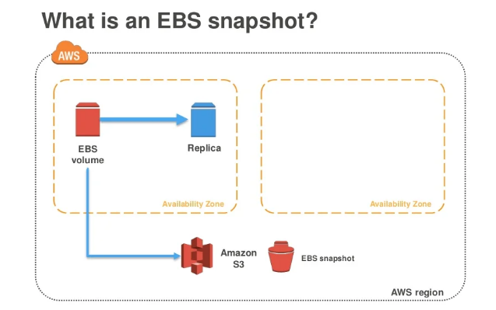

<https://www.slideshare.net/AmazonWebServices/backing-up-amazon-ec2-with-amazon-ebs-snapshots-june-2017-aws-online-tech-talks>

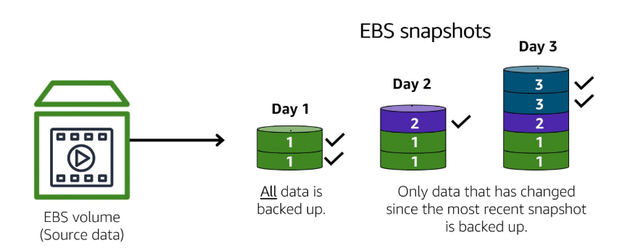

You can back up the data on your Amazon EBS volumes to Amazon S3 by taking point-in-time snapshots. Snapshots are incremental backups, which means that only the blocks on the device that have changed after your most recent snapshot are saved. This minimizes the time required to create the snapshot and saves on storage costs by not duplicating

Snapshot link:

<https://docs.aws.amazon.com/AWSEC2/latest/UserGuide/EBSSnapshots.html>

**Contents**

* [How incremental snapshots work](https://docs.aws.amazon.com/AWSEC2/latest/UserGuide/EBSSnapshots.html#how_snapshots_work)
* [Copy and share snapshots](https://docs.aws.amazon.com/AWSEC2/latest/UserGuide/EBSSnapshots.html#copy-and-share)
* [Encryption support for snapshots](https://docs.aws.amazon.com/AWSEC2/latest/UserGuide/EBSSnapshots.html#encryption-support)
* [Create Amazon EBS snapshots](https://docs.aws.amazon.com/AWSEC2/latest/UserGuide/ebs-creating-snapshot.html)
* [Delete an Amazon EBS snapshot](https://docs.aws.amazon.com/AWSEC2/latest/UserGuide/ebs-deleting-snapshot.html)
* [Copy an Amazon EBS snapshot](https://docs.aws.amazon.com/AWSEC2/latest/UserGuide/ebs-copy-snapshot.html)
* [Archive Amazon EBS snapshots](https://docs.aws.amazon.com/AWSEC2/latest/UserGuide/snapshot-archive.html)
* [View Amazon EBS snapshot information](https://docs.aws.amazon.com/AWSEC2/latest/UserGuide/ebs-describing-snapshots.html)
* [Share an Amazon EBS snapshot](https://docs.aws.amazon.com/AWSEC2/latest/UserGuide/ebs-modifying-snapshot-permissions.html)
* [Recover snapshots from the Recycle Bin](https://docs.aws.amazon.com/AWSEC2/latest/UserGuide/recycle-bin-working-with-snaps.html)
* [Amazon EBS local snapshots on Outposts](https://docs.aws.amazon.com/AWSEC2/latest/UserGuide/snapshots-outposts.html)
* [Use EBS direct APIs to access the contents of an EBS snapshot](https://docs.aws.amazon.com/AWSEC2/latest/UserGuide/ebs-accessing-snapshot.html)
* [Automate the snapshot lifecycle](https://docs.aws.amazon.com/AWSEC2/latest/UserGuide/automating-snapshots.html)

What is Elastic IP address?

An Elastic IP address is a static IPv4 address designed for dynamic cloud computing. An Elastic IP address is allocated to your AWS account, and is yours until you release it. By using an Elastic IP address, you can mask the failure of an instance or software by rapidly remapping the address to another instance in your account. Alternatively, you can specify the Elastic IP address in a DNS record for your domain, so that your domain points to your instance. For more information, see the documentation for your domain registrar, or [Set up dynamic DNS on Your Amazon Linux instance](https://docs.aws.amazon.com/AWSEC2/latest/UserGuide/dynamic-dns.html).

An Elastic IP address is a public IPv4 address, which is reachable from the internet. If your instance does not have a public IPv4 address, you can associate an Elastic IP address with your instance to enable communication with the internet. For example, this allows you to connect to your instance from your local computer.

Elastic Ip Link :

<https://docs.aws.amazon.com/AWSEC2/latest/UserGuide/elastic-ip-addresses-eip.html>

How to assign Elastic Ip?

Below Link

<https://cloudkatha.com/how-to-assign-elastic-ip-address-to-your-ec2-instance-in-aws/>

**Contents**

* [Elastic IP address pricing](https://docs.aws.amazon.com/AWSEC2/latest/UserGuide/elastic-ip-addresses-eip.html#eip-pricing)
* [Elastic IP address basics](https://docs.aws.amazon.com/AWSEC2/latest/UserGuide/elastic-ip-addresses-eip.html#eip-basics)
* [Work with Elastic IP addresses](https://docs.aws.amazon.com/AWSEC2/latest/UserGuide/elastic-ip-addresses-eip.html#working-with-eips)
* [Use reverse DNS for email applications](https://docs.aws.amazon.com/AWSEC2/latest/UserGuide/elastic-ip-addresses-eip.html#Using_Elastic_Addressing_Reverse_DNS)
* [Elastic IP address limit](https://docs.aws.amazon.com/AWSEC2/latest/UserGuide/elastic-ip-addresses-eip.html#using-instance-addressing-limit)